**Report 2**

**Progress Made:**

1. About Section is added.
2. Section for Products made in India is added but their detailed info is yet to be added. For time being I have added only categories of products which are:
   1. Food and Beverages
   2. Electronics
   3. Mobile Applications
3. Footer is added.
4. Also made some changes to the body header and navbar.
5. All the added sections are responsive.

**Technologies used:**

HTML 5

CSS 3

Bootstrap v4.0

JavaScript for using Bootstrap features

Also link to fontawesome CDN is added which is used for the icon attached in footer section and products section.

**Fonts used:**

These font families are taken from Google fonts

For logo: Font family used is ‘Merienda One’.

For heading in the header: Font family used is ‘Libre Baskerville’.

For section heading: Font family used is ‘Righteous’.

**Snapshot of Home Page**

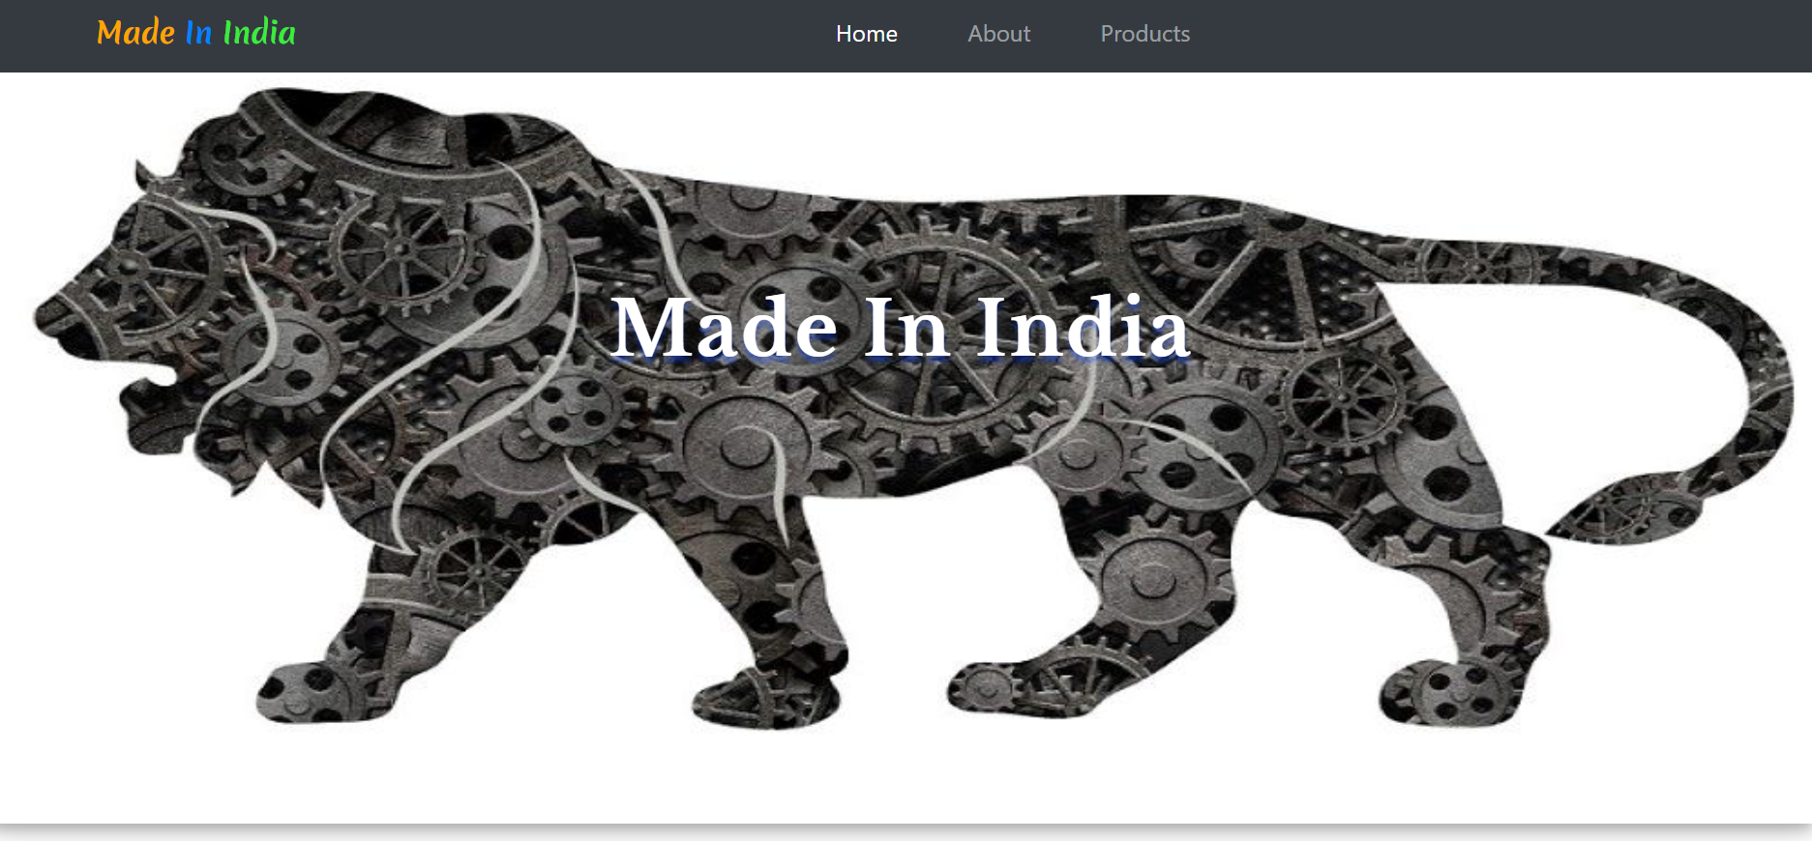

**Snapshot of About Section**

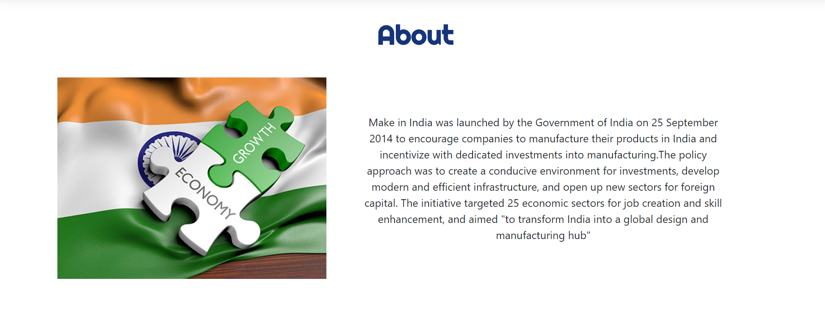

**Snapshot of Products Section**

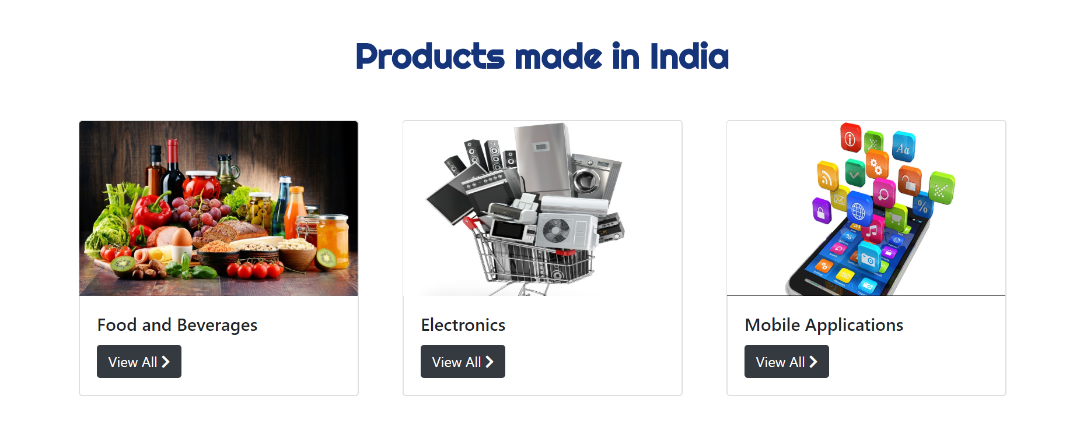

**Snapshot of Footer Section**



**Image and text Credits:**

About paragraph information taken from Wikipedia.

<https://en.wikipedia.org/wiki/Make_in_India>

About section image credits- <https://economictimes.indiatimes.com/news/economy/indicators/indian-economy-needs-additional-reforms-kkrs-david-petraeus/articleshow/76900898.cms>

**Products section images credits**

food and drinks card image - <https://www.azom.com/article.aspx?ArticleID=18224>

electronics card image- <https://www.business-standard.com/article/companies/indian-electronics-market-to-be-228-bn-in-2020-esdm-117022101200_1.html>

apps card image- <https://yourstory.com/mystory/2bf0eb5346-here-is-why-you-need-a>

**Things to be done next:**

* Add the detailed info about Products made in India
* Add the information about which foreign product is substituted by Indian Product.